

Mathematics Department |  | 
Course: A2MAA
Topic Title: Test 3 Calculator Free
Student Name:_____________________________________ | Date: ____________
Special Instructions: Formula Sheet allowed and no calculators | Time Allowed: 10 minutes
Show all working clearly | Marks: / 10

Question 1. (4 marks)

Use the triangle below to obtain the fractions for the trigonometric ratios given.

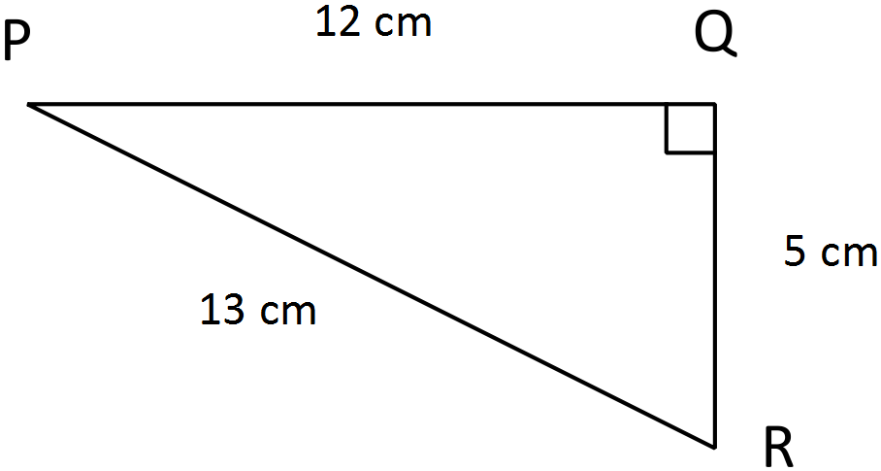
- sin P = _________

- sin R = _________

- cos R = ________

- tan P = ________

Question 2. (2 marks)

If $sin30=0.5$ , calculate the length of the missing side.

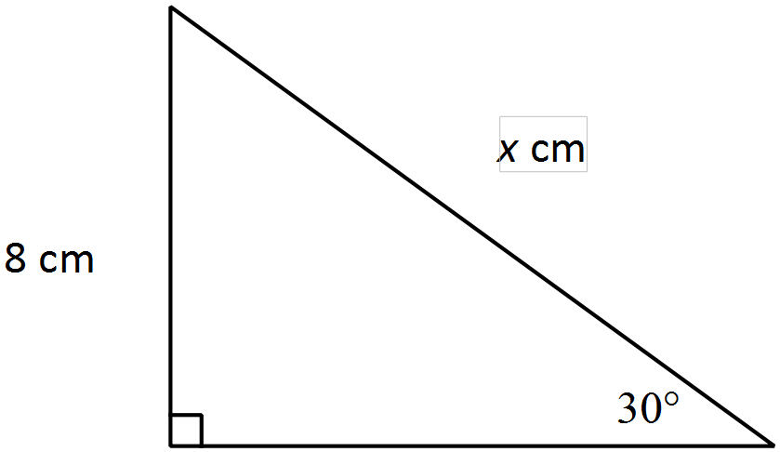

Question 3. (2 marks)

Calculate the bearing of A from B in the following two scenarios.

- 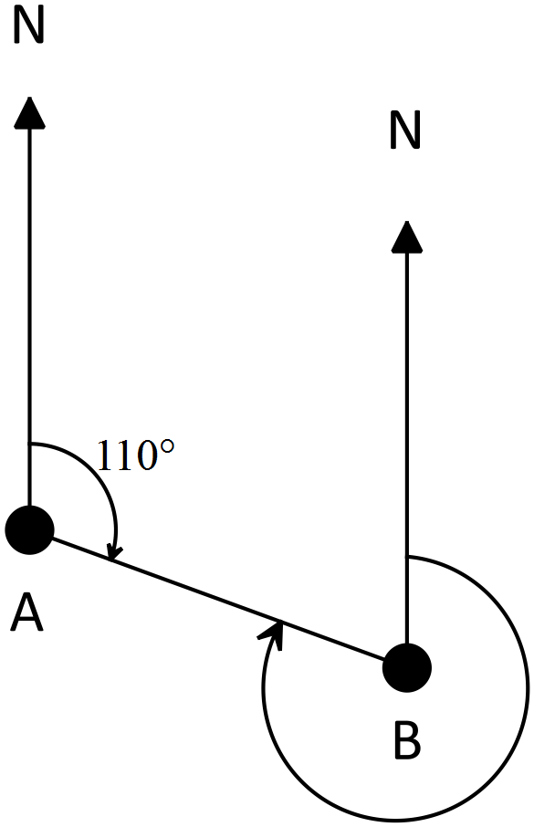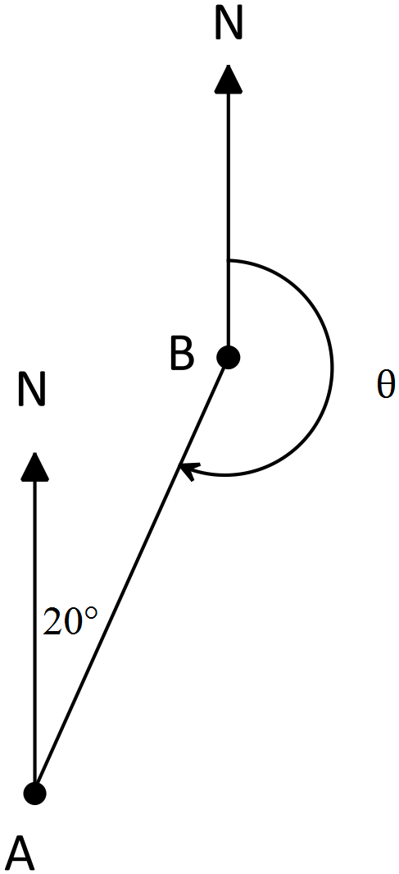b)

Question 4. (2 marks)

If $sin30=0.5$, calculate the area of the triangle below.

